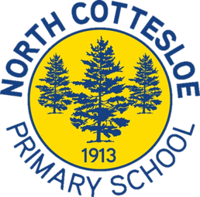
Concert Band
Welcome to Term 1

Dear Parents, Caregivers and Students,

Hello and welcome to Concert Band for 2023!
Concert Band is an ensemble for students in Years 5 – 6 who play flute, clarinet, saxophone, trumpet, trombone and percussion. The ensemble provides outstanding opportunities for students to play on their instrument, develop as musicians and enjoy the social benefits of interacting with children from other classes and year levels whilst under the direction of a conductor. The ensemble aims to provide a high standard of ensemble experience whilst instilling a life-long love of music.
Ensemble rehearsals and performances focus very much on working as a group, with every member taking responsibility for their own part. Students must be having a weekly lesson on their instrument to be a member of this ensemble. Concert Band is a compulsory ensemble for students in our Woodwind and Brass IMSS Program. Students new to North Cottesloe Primary with musical experience on brass, woodwind or percussion instruments are welcome to audition for Concert Band.
Our rehearsals will be held in the undercover area on Friday mornings from 8.10 – 9 am. Our first rehearsal for the term will be on Friday the 10th of February. It is imperative that students arrive at rehearsals on time ready to start on rehearsal days. The majority of what we learn or rehearse during rehearsals greatly affects the individual student as well as the rest of the group. If students are absent from concert band, it makes it difficult for the conductor and ensemble members to have an accurate idea of sound, balance, blend and progress. For duty of care purposes, please email me directly if your child is unable to attend a rehearsal or performance.
We have an exciting year of performances ahead of us including performances at a variety of school assemblies and services, as well as performances in the local community. Information regarding extra rehearsals and performance events will be sent out to families via connect throughout the year.

Students in the Year 5 IMSS Program will join concert band rehearsals once they have established the fundamentals on their instrument. Mrs Fine will work closely with the IMSS teachers to monitor and assess student readiness for concert band.

If you have any questions regarding Concert Band, please feel free to contact me. I want to thank you for your continued support of the Music program at North Cottesloe Primary School.

Best wishes,

Jennifer Fine

