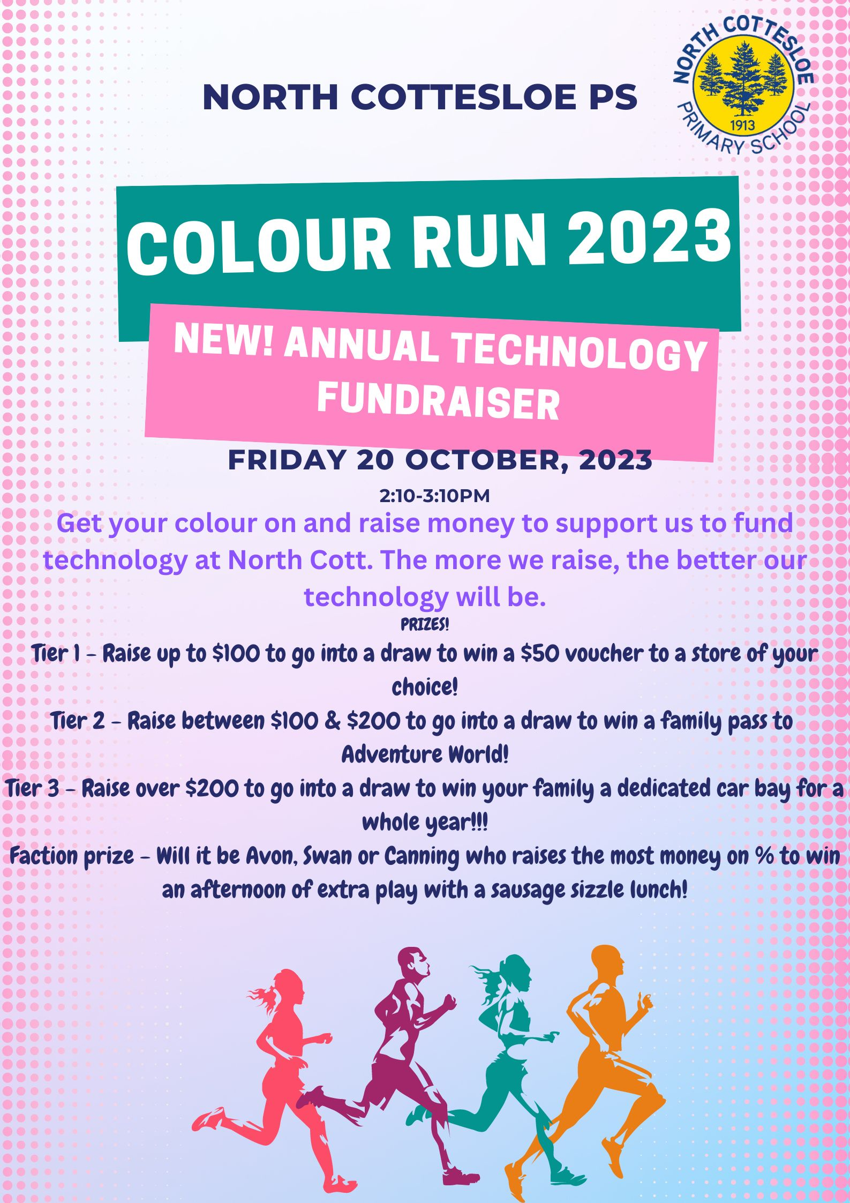

Dear Parents and Carers,
On 20 October 2023 North Cottesloe will be holding a Colour Run, to fundraise for all of our Technology needs in 2024. As a minimum, we hope to raise the equivalent of $200 per student from Kindergarten to Year 6, to meet our expected costs for Technology next year.
When: Friday 20 October 2023, from 2:10pm – 3:10pm
Where: North Cottesloe ovals
We are asking students to find sponsors for this event between NOW and 20 October 2023. We do not support students seeking sponsorship by going door to door. Please assist your children in how they might find sponsors through family, friends, parents’ places of work, local sports clubs etc. Sponsorship may be in the form of an amount per lap, or as a donation for participation in the event, irrespective of the number of laps completed. There are tiered prize structures for monies raised. Please check our community notice board for what these prize structures are.
We ask everyone to start NOW, to collect money and sponsors prior to the event. All forms and money need to be deposited to the school’s account by Monday 23 October 2023, referencing your child’s name and COLOUR and your child’s name.
Students are encouraged to dress up for the Colour Run and be ready to come home colourful! Wigs, tutus, shirts to show off some colour, sunglasses crazy socks, and crazy hair are all acceptable attire for the event.
Student Name: ______________________ Room: _________________
Number of Laps completed: _____________________________________

Sponsor Name | Contact Details | Amount Per Lap | Donation  (If preferred) | Total to be collected | Tick when collected
Sponsor Name | Contact Details | Amount Per Lap | Donation  (If preferred) | Total to be collected | Tick when collected

Total Amount Sponsored: _______________
Total Amount Collected: _______________

Your support in helping us raise funds for our Technology needs in 2024 is appreciated and we look forward to a fun and colour filled event on 20 October 2023.
Thank you!
Deposit all money for the Colour Run referencing COLOUR and your child’s name to:
BSB
016 281
Account
3408 67487

North Cottesloe Primary School Students and Staff

