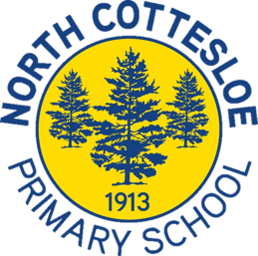
Vocal Ensemble
Welcome to Term 1

Dear Parents, Caregivers and Students,

Hello and welcome to Vocal Ensemble for 2023!

Vocal Ensemble is for students in Years 4 – 6 who enjoy singing, reading and performing music in the context of a group. If your child would like to sign up for Vocal Ensemble, please complete the registration form by clicking here. This registration form must be completed by new and returning ensemble members.
Our rehearsals will be held on Wednesday mornings from 8.10 – 9 am. Rehearsals will be held in the undercover area. Our first rehearsal for the term will be on Wednesday the 8thof February. It is imperative that students arrive at rehearsals on time ready to start on rehearsal days. The majority of what we learn or rehearse during rehearsals greatly affects the individual student as well as the rest of the group. If students are absent from choir, it makes it difficult for the conductor and ensemble members to have an accurate idea of sound, balance, blend and progress. For duty of care purposes, please email me directly if your child is unable to attend a rehearsal or performance.
We have an exciting year of performances ahead of us including performances at school assemblies and services, Massed Choir Festival, WAGSMS, Graduation Ceremonies, Cottesloe Hullabaloo and Cottesloe Carols by Candlelight. Information regarding extra rehearsals and performance events will be sent out to families via connect throughout the year.

If you have any questions regarding Vocal Ensemble, please feel free to contact me. I want to thank you for your continued support of the Music program at North Cottesloe Primary School.

Best wishes,

Jennifer Fine
Music Specialist

